MAT 230 Module Eight Homework

General:
- Before beginning this homework, be sure to read the textbook sections and the material in Module Eight.
- Type your solutions into this document and be sure to show all steps for arriving at your solution. Just giving a final number may not receive full credit.
- You may copy and paste mathematical symbols from the statements of the questions into your solution. This document was created using the Arial Unicode font.
- These homework problems are proprietary to SNHU COCE. They may not be posted on any non-SNHU website.
- The Institutional Release Statement in the course shell gives details about SNHU’s use of systems that compare student submissions to a database of online, SNHU, and other universities’ documents.

- Draw a picture of the graph G = (V, E, γ) where V = {t, u, v, w, z}, E = {e₁, e₂, e₃, e₄, e₅}, and γ(e₁) = {v, w}, γ(e₂) = {t, u}, γ(e₃) = {t, v}, γ(e₄) = {u, w}, γ(e₅) = {t, w}. You may use (copy/paste/move/resize/etc.) the images below to create your graph.
This problem is similar to Examples 1 and 2 and to Exercises 7 and 8 in Section 8.1 of your SNHU MAT230 textbook.

z
w
v
u
t

- Consider Kn, the complete graph on n vertices. Explain how you calculated your answers.
  - What is the degree of each vertex?
  - How many edges does K_{n} have?
This problem is similar to Example 6 and to Exercises 13 and 14 in Section 8.1 of your SNHU MAT230 textbook.

- Does the following graph have an Euler circuit, an Euler path, both, or neither? Give reasons for your decision.
This problem is similar to Examples 4 and 5 and to Exercises 1–8 in Section 8.2 of your SNHU MAT230 textbook.
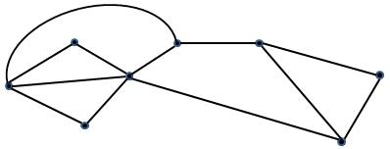

- Does the following graph have an Euler circuit, an Euler path, both, or neither? Give reasons for your decision.
This problem is similar to Examples 4 and 5 and to Exercises 1–8 in Section 8.2 of your SNHU MAT230 textbook.
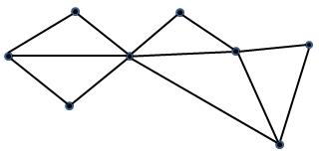

- Use Fleury’s algorithm to produce an Euler circuit for the following graph. Start at A and label the edges in the order that you add them. Below are images you can use to number the graph.
This problem is similar to Example 6 and to Exercises 11 and 12 in Section 8.2 of your SNHU MAT230 textbook.

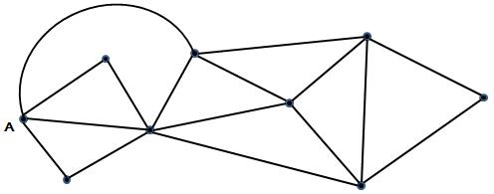

13
14
12
6
10
16
15
5
7
11
8
3
2
1
4
9

